Human Development Index (HDI) Prediction
Project Description:
The Human Development Index (HDI) Prediction System is a Machine Learning-based web application developed to predict the Human Development Index category of a country using important socio-economic indicators. The application helps users estimate whether a country's development level falls under Low, Medium, High, or Very High Human Development based on four essential input parameters: Life Expectancy, Mean Years of Schooling, Expected Years of Schooling, and Gross National Income (GNI) per Capita.
The system is developed using the Flask web framework and integrates a trained Machine Learning model for real-time prediction. The frontend is designed using HTML, CSS, and JavaScript, providing a responsive and user-friendly interface. Users enter the required development indicators through the web application, and the system instantly predicts the corresponding HDI category with high accuracy.
The backend loads the trained Machine Learning model and preprocessing components using Python libraries such as Pickle and Scikit-learn. After validating the user inputs, the application processes the data through the trained model and displays the prediction with a clear and visually appealing result, making it easy to interpret the country's development status.
Scenarios

Scenario 1: Government Development Planning
A government planning officer wants to estimate the Human Development Index category after implementing improvements in healthcare, education, and income. By entering updated values for Life Expectancy, Mean Years of Schooling, Expected Years of Schooling, and GNI per Capita, the system predicts the country's HDI category, helping policymakers evaluate the effectiveness of proposed development strategies.

Scenario 2: Educational Research

A university student or researcher is conducting research on global human development. The researcher collects socio-economic indicators for different countries and uses the HDI Prediction System to estimate their Human Development Index categories. The predictions assist in comparing development levels across countries and understanding how various socio-economic factors influence human development.

Scenario 3: Economic and Social Analysis
An economist or policy analyst studies the relationship between education, healthcare, and national income. By entering different combinations of development indicators into the application, the analyst observes changes in the predicted HDI category. This helps identify the most influential factors affecting human development and supports evidence-based decision-making for future policy planning.

Technical Architecture:

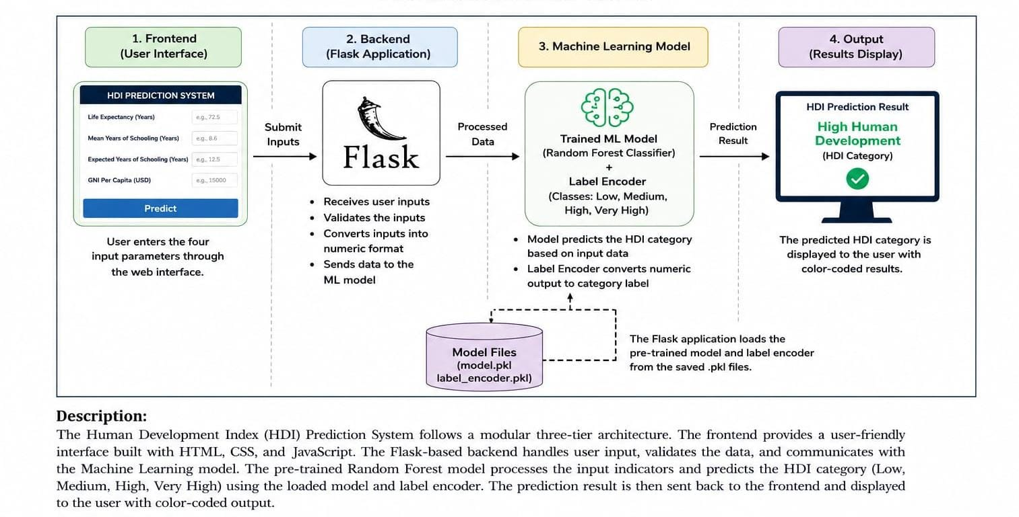

Pre-requisites:

- Flask Framework Knowledge: Flask Documentation
- Python Programming Proficiency: Python Documentation
- Machine Learning Basics: Scikit-learn Documentation
- HTML, CSS, and JavaScript Skills: W3Schools HTML/CSS Tutorials
- Version Control with Git: Git Documentation
- Development Environment Setup: Flask Installation Guide
- Libraries and Tools: NumPy Documentation. Pickle Module (Python Docs)
Project Workflow:

Milestone 1: Machine Learning Model Development
- Activity 1.1: Collect and preprocess the Human Development Index (HDI) dataset by selecting relevant development indicators such as Life Expectancy, Mean Years of Schooling, Expected Years of Schooling, and Gross National Income (GNI) per Capita.
- Activity 1.2: Analyze the dataset by handling missing values, validating data quality, and preparing the features for machine learning.
- Activity 1.3: Select an appropriate Machine Learning classification algorithm for predicting the HDI category.
- Activity 1.4: Train the Machine Learning model using the processed dataset and save the trained model and label encoder using Pickle for future predictions.

Milestone 2: Core Functionalities Development
- Activity 2.1: Develop the Flask backend to receive user inputs, validate the data, process the prediction request, and communicate with the trained Machine Learning model.
- Activity 2.2: Implement the prediction functionality that accepts user inputs, converts them into numerical format, performs prediction using the trained model, and converts the output into a readable HDI category.

Milestone 3: App.py Development
• Activity 3.1: Develop the main application logic in app.py, including Flask routing, model loading, prediction processing, exception handling, and communication between the frontend and backend.

Milestone 4: Frontend Development
- Activity 4.1: Design a responsive and user-friendly web interface using HTML and CSS for collecting user inputs and displaying prediction results.
- Activity 4.2: Create separate webpages for the project dashboard and prediction interface, ensuring smooth navigation and an attractive user experience.

Milestone 5: Deployment and Testing
- Activity 5.1: Configure the application environment by installing all required libraries and dependencies.
- Activity 5.2: Deploy the Flask application locally, verify all functionalities, test different input combinations, and validate prediction accuracy and application performance.

Milestone 6: Conclusion
• Activity 6.1: Evaluate the overall performance of the Human Development Index Prediction System, verify the correctness of prediction results, and identify possible future enhancements such as data visualization, explainable AI techniques, prediction history, and cloud deployment.

Milestone 1: Machine Learning Model Development
In this milestone, the primary objective is to develop a Machine Learning model capable of predicting the Human Development Index (HDI) category based on important socio-economic indicators. This phase includes collecting and preprocessing the dataset, selecting the appropriate machine learning algorithm, training the prediction model, and saving the trained model for deployment within the Flask web application. A well-trained model ensures accurate, reliable, and efficient prediction of HDI categories such as Low, Medium, High, and Very High Human Development.

Activity 1.1: Dataset Collection and Preprocessing
Before building the Human Development Index Prediction System, it is essential to collect a reliable dataset containing the development indicators that directly influence the HDI category. The dataset must then be cleaned and preprocessed to improve the performance and accuracy of the Machine Learning model.

Step 1 – Collect the HDI Dataset
Download the Human Development Index dataset from a trusted source such as:
- United Nations Development Programme (UNDP)
- World Bank Open Data
- Kaggle HDI Dataset
- Human Development Reports
The dataset should contain the following attributes:
- Country Name
- Life Expectancy at Birth
- Mean Years of Schooling
- Expected Years of Schooling
- Gross National Income (GNI) Per Capita
- Human Development Index Category (Target Variable)
These indicators are internationally recognized and are used by the United Nations to measure the overall development level of countries.

Step 2 – Import Required Libraries
Before loading the dataset, import the required Python libraries for data processing and Machine Learning.
import pandas as pd import numpy as np from sklearn.model_selection import train_test_split from sklearn.preprocessing import LabelEncoder
These libraries are used for data manipulation, preprocessing, feature encoding, and dataset preparation.

Step 3 – Load the Dataset
Load the HDI dataset into Python using the Pandas library. dataset = pd.read_csv("hdi_dataset.csv")
After loading the dataset, verify that it has been imported correctly by displaying the first few records.
dataset.head()

Step 4 – Explore the Dataset
Before training the Machine Learning model, analyze the dataset to understand its structure and quality.
Perform the following operations:
- Display the first five rows.
- Check the total number of records.
- Verify data types of each feature.
- Identify missing values.
- Calculate summary statistics.
- Detect duplicate records.
Example:
dataset.info()

dataset.describe()

dataset.isnull().sum()

dataset.duplicated().sum()
This analysis helps identify inconsistencies and prepares the dataset for preprocessing.

Step 5 – Data Cleaning
Data preprocessing is one of the most important steps in Machine Learning.
Perform the following preprocessing tasks:
- Remove duplicate records.
- Handle missing or null values.
- Verify numerical data consistency.
- Remove invalid or unrealistic values.
- Ensure all features are in the correct format.
- Encode the HDI category using a Label Encoder.
These preprocessing techniques improve the overall accuracy and reliability of the prediction model.

Step 6 – Select Input Features
The Human Development Index Prediction System uses the following four features as input variables:
- Life Expectancy
- Mean Years of Schooling
- Expected Years of Schooling
- Gross National Income (GNI) Per Capita
These indicators represent the three major dimensions of human development:
- Health
- Education
- Standard of Living
The selected features are provided by the user through the web application and passed to the trained Machine Learning model for prediction.

Step 7 – Split the Dataset
Finally, divide the dataset into training and testing datasets. A commonly used split ratio is: • 80% Training Dataset
• 20% Testing Dataset Example:
X_train, X_test, y_train, y_test = train_test_split(
X,
y,
test_size=0.20, random_state=42
)

The training dataset is used to train the Machine Learning model, while the testing dataset evaluates its prediction accuracy on unseen data

Activity 1.2: Research and Select the Appropriate Machine Learning Model
Selecting the appropriate Machine Learning algorithm is an essential step in developing the Human Development Index (HDI) Prediction System. The prediction model should accurately classify the HDI category based on important socio-economic indicators while maintaining high prediction accuracy and fast execution time. Before selecting the final model, different Machine Learning classification algorithms were researched and evaluated according to their performance, computational efficiency, and suitability for the available dataset.

Activity 1.3: Define the Architecture of the Application
The Human Development Index (HDI) Prediction System follows a simple three-tier architecture consisting of the Presentation Layer (Frontend), Application Layer
(Backend), and Machine Learning Layer. This architecture ensures smooth communication between the user interface, Flask application, and the trained Machine Learning model. The user enters the required development indicators through the web interface, the backend processes the request, and the trained model predicts the corresponding HDI category.

Activity 1.4: Set Up the Development Environment
Before developing and running the Human Development Index (HDI) Prediction System, it is important to configure the development environment correctly. This includes installing Python, creating a virtual environment, installing the required libraries, and organizing the project files. A properly configured environment ensures that the application runs smoothly and all project dependencies are managed efficiently.

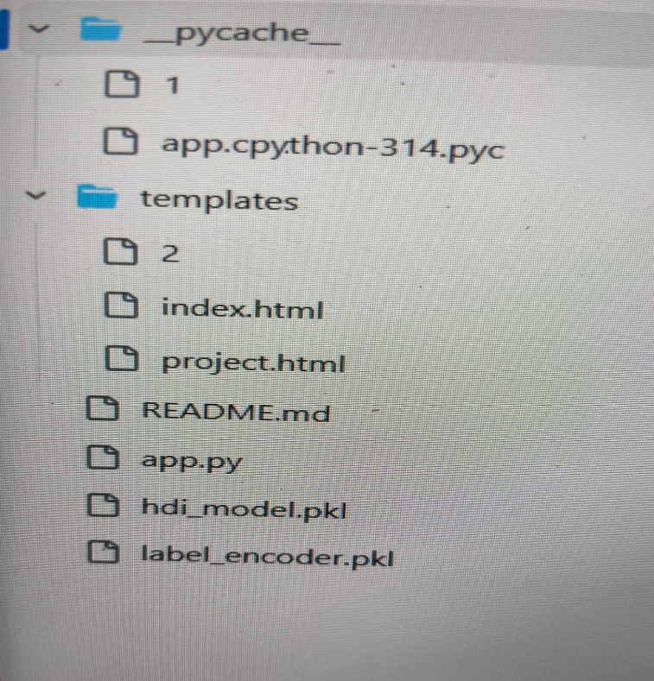

-Milestone 2: Core Functionalities Development
The second milestone focuses on implementing the core functionalities of the Human Development Index (HDI) Prediction System. In this phase, the Machine Learning model is integrated with the Flask application, allowing users to submit development indicators and receive real-time HDI predictions. The backend processes user inputs, performs prediction using the trained model, and returns the predicted HDI category through the web interface.

Activity 2.1: Develop the Core Prediction Functionality
The core functionality of the HDI Prediction System is to predict the Human Development Index category based on four important socio-economic indicators. The application accepts user input, validates the data, converts it into a format suitable for the Machine Learning model, and displays the prediction instantly.

Milestone 3: App.py Development
Milestone 3 focuses on developing the app.py file, which serves as the core of the Human Development Index (HDI) Prediction System. This file manages the communication between the user interface and the Machine Learning model. It is responsible for handling user requests, validating input values, loading the trained model, generating predictions, and displaying the results on the web page.

Activity 3.1: Writing the Main Application Logic in app.py
The app.py file is the main entry point of the application. It initializes the Flask framework, loads the trained Machine Learning model and Label Encoder, defines the application routes, and processes prediction requests.

Define the Flask Application
The Flask application is initialized, and the required libraries are imported. The trained Machine Learning model and Label Encoder are loaded using the Pickle library.

from flask import Flask, render_template, request import pickle
import numpy as np

app = Flask(__name__)

model = pickle.load(open("hdi_model.pkl", "rb"))
label_encoder = pickle.load(open("label_encoder.pkl", "rb"))

Define the Application Routes
The application contains three main routes that perform different functions. Home Route
The home route displays the project dashboard.
@app.route("/") def home():
return render_template("index.html")

Project Route
This route opens the prediction interface where users enter the development indicators.

@app.route("/launch") def launch():
return render_template("project.html")

Prediction Route
The prediction route receives the user input, validates the values, processes the data, and generates the HDI prediction.

@app.route("/predict", methods=["GET", "POST"]) def predict():

Processing User Input
When the user submits the prediction form, the Flask application performs the following operations:
- Reads the values entered by the user.
- Validates that all fields contain valid numerical values.
- Converts the values into floating-point numbers.
- Creates a NumPy array containing the input features. Example:

features = np.array([[ life_expectancy, mean_years_schooling, expected_years_schooling,
gni_per_capita
]])

Machine Learning Prediction
After preparing the feature array, the trained Machine Learning model predicts the Human Development Index category.
The predicted numerical value is converted into the corresponding category using the Label Encoder.

prediction = model.predict(features)
result = label_encoder.inverse_transform(prediction)[0]

The application then sends the prediction result to the HTML page for display.

Error Handling
To improve reliability, the prediction process is enclosed within a try-except block. If invalid data or unexpected errors occur, the application displays an informative error message instead of terminating unexpectedly.
This improves the stability and usability of the HDI Prediction System.

Milestone 4: Frontend Development
Milestone 4 focuses on designing and developing a user-friendly, responsive, and visually appealing interface for the Human Development Index (HDI) Prediction System. The frontend is developed using HTML5 and CSS3, providing an intuitive environment where users can enter development indicators and instantly view the predicted HDI category. The interface is designed to improve usability while maintaining a clean and professional appearance across different devices.

Activity 4.1: Designing and Developing the User Interface
The frontend of the application serves as the interaction layer between the user and the Machine Learning prediction system. It provides a simple navigation flow, allowing users to access the prediction tool and obtain results efficiently.

Design the Homepage
The homepage acts as the landing page of the application and provides an overview of the Human Development Index Prediction System. It introduces the project, explains its purpose, and includes a button that redirects users to the prediction page.
The homepage contains:
- Project Title
- Project Description
- Project Goal
- Importance of HDI Prediction
- "Open Predictor" Button
This layout helps users understand the purpose of the application before using the prediction system.

Activity 4.2: Creating Dynamic Content Rendering
The Human Development Index (HDI) Prediction System dynamically displays prediction results based on the values entered by the user. The Flask backend processes the submitted data, performs prediction using the trained Machine Learning model, and returns the result to the frontend. The prediction page updates automatically and displays the predicted HDI category without requiring users to manually navigate between different pages.

Milestone 5: Deployment
Milestone 5 focuses on preparing the Human Development Index (HDI) Prediction System for execution in a local development environment. This stage includes configuring the Python environment, installing the required libraries, verifying the project structure, and running the Flask application. Proper deployment ensures that the Machine Learning model, backend, and frontend work together to provide accurate real-time predictions.

Activity 5.1: Preparing the Application for Local Deployment
Before running the application, all required software, libraries, and project files must be properly configured.

Set Up a Virtual Environment
- A virtual environment is used to isolate project dependencies from other Python projects installed on the computer.
- Open Command Prompt or Visual Studio Code Terminal, then create a virtual environment using the following command:

python -m venv myenv

Activate the virtual environment.

Activity 5.2: Local Testing and Verification
After configuring the development environment and installing all required dependencies, the next step is to test the Human Development Index (HDI) Prediction System locally. Local testing ensures that the Flask application, Machine Learning model, and user interface work correctly before deployment.

Start the Flask Development Server
Activate the virtual environment and run the Flask application using the following command:

python app.py

If the application starts successfully, the terminal displays a message similar to:

- Running on http://127.0.0.1:5000/
- Debug mode: On

This indicates that the Flask server is running successfully and is ready to receive user requests.

Open the Application in a Web Browser
Launch a web browser such as Google Chrome, Microsoft Edge, or Mozilla Firefox, and open the following address:

http://127.0.0.1:5000/

The homepage of the Human Development Index (HDI) Prediction System will appear. From there, click the Open Predictor button to access the prediction interface.

Exploring the Website’s Web Pages:
Home / Generator Page:

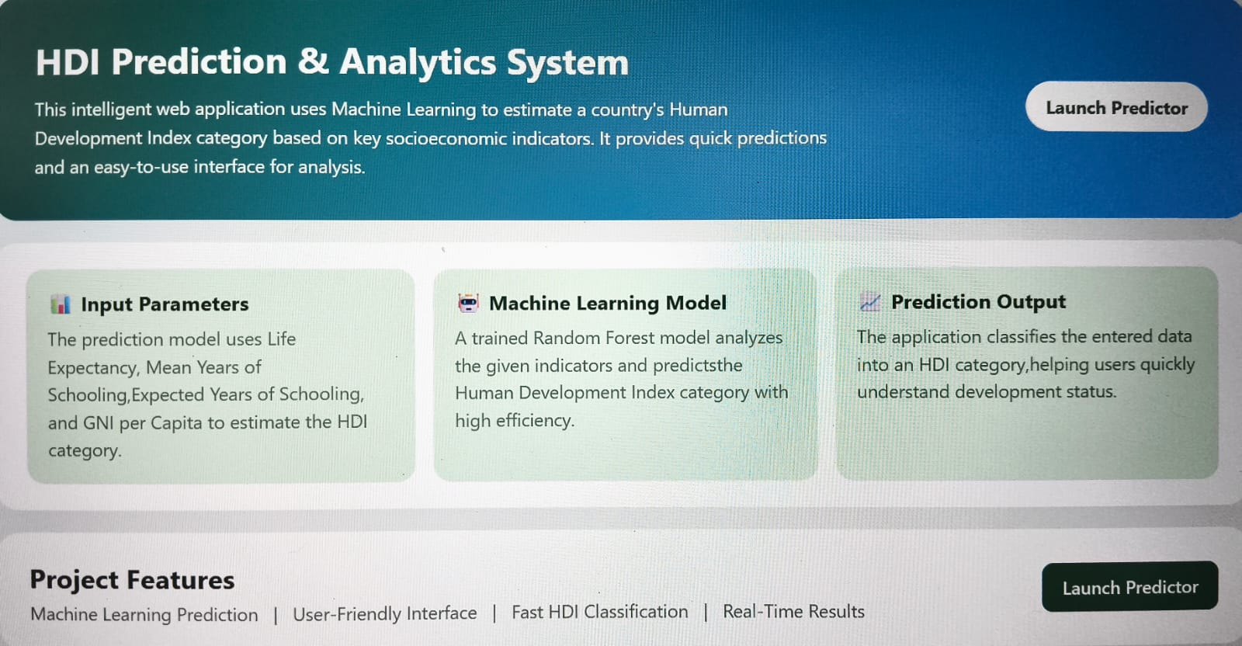

Description: The Home Page serves as the landing page of the Human Development Index (HDI) Prediction System. It introduces users to the purpose of the application and provides an overview of the project. The page is designed with a modern, responsive interface using HTML and CSS, making it easy to navigate and visually appealing.
The homepage contains a brief introduction explaining how Machine Learning is used to predict the Human Development Index category based on socio-economic indicators. It also includes a navigation button that redirects users to the prediction interface.
The design focuses on simplicity and usability, ensuring that users can quickly understand the project before accessing the prediction module.

Input Section:

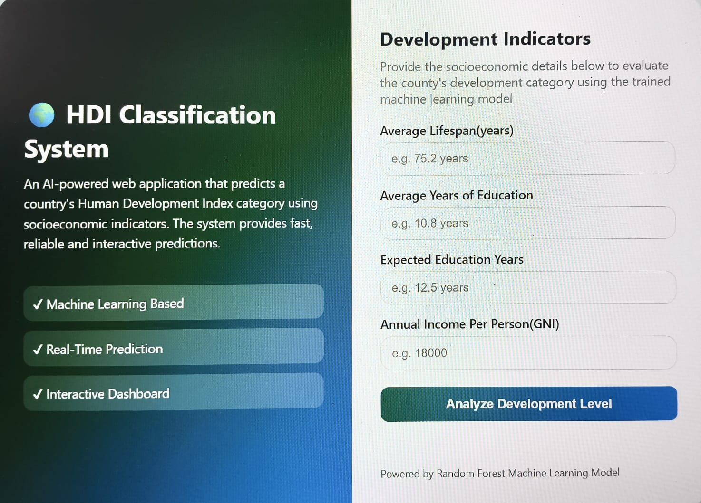
Description: The Prediction Page is the primary interface of the Human Development Index (HDI) Prediction System, where users interact with the Machine Learning model. This page allows users to enter the required socio-economic indicators and receive an instant prediction of the Human Development Index category. The interface is designed to be responsive, user-friendly, and visually appealing, ensuring a smooth experience across desktop and mobile devices.
The prediction form collects four important development indicators that directly influence the Human Development Index. Once the user submits the form, the Flask backend processes the data, performs prediction using the trained Machine Learning model, and displays the predicted HDI category on the same page.
Results Section:
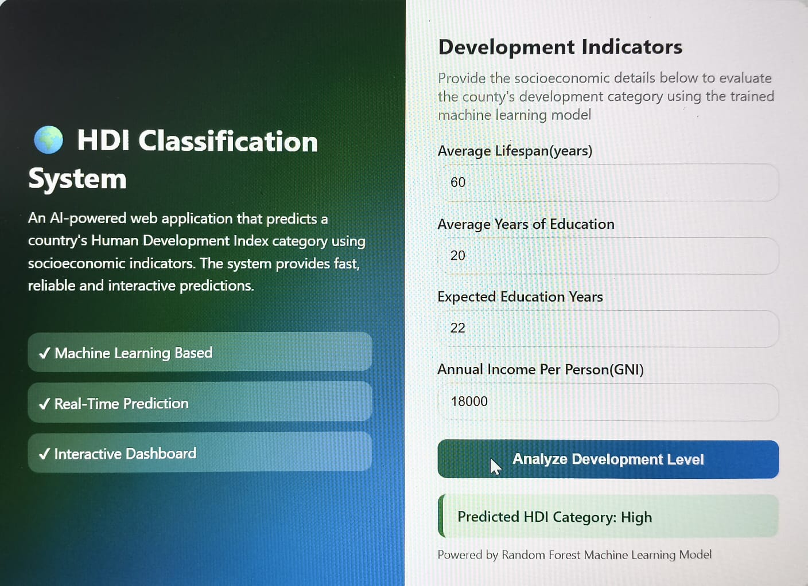

Description: After the prediction process is completed, the application displays the output directly below the input form. The result section includes:
- Predicted Human Development Index (HDI) Category.
- Color-coded result message for easy interpretation.
- Previously entered input values.
- A clear indication of whether the predicted category is Low, Medium, High, or Very High Human Development.
This approach allows users to review their submitted values and perform additional predictions without re-entering all the information.

Conclusion:
The Human Development Index (HDI) Prediction System is a Machine Learning-based web application developed to predict the Human Development Index category of a country using important socio-economic indicators such as Life Expectancy, Mean Years of Schooling, Expected Years of Schooling, and Gross National Income (GNI) Per Capita. The system successfully integrates Machine Learning with the Flask web framework to provide real-time predictions through a simple, responsive, and user-friendly interface.

The application demonstrates how Artificial Intelligence and Machine Learning can support the analysis of human development by transforming statistical indicators into meaningful predictions. The trained Machine Learning model processes user-provided data efficiently and classifies the country into one of the Human Development Index categories: Low, Medium, High, or Very High Human Development. The prediction results are displayed instantly with color-coded indicators, improving readability and user experience.

Throughout the project, all major development phases—including dataset collection, data preprocessing, Machine Learning model development, Flask backend implementation, frontend interface design, testing, and deployment preparation—were completed successfully. The integration of HTML, CSS, Python, Flask, NumPy, and Scikit-learn demonstrates the practical application of modern web technologies with Machine Learning techniques.

The Human Development Index Prediction System can serve as a valuable educational and analytical tool for students, researchers, policy analysts, and government organizations interested in understanding the relationship between education, healthcare, income, and overall human development. It provides a simple method for estimating the development category of a country based on key indicators and can support research, planning, and awareness activities.

Future improvements can further enhance the application by incorporating interactive dashboards, graphical visualization of prediction results, prediction history using a database, user authentication, PDF report generation, cloud deployment, and Explainable Artificial Intelligence (XAI) techniques such as SHAP or LIME to improve transparency and interpretability of the Machine Learning model. Integration with real-time datasets from organizations such as the United Nations Development Programme (UNDP) or the World Bank would also improve prediction accuracy and practical usability.

In conclusion, the Human Development Index Prediction System successfully demonstrates the effective integration of Machine Learning and web technologies to solve a real-world problem. The project highlights the importance of predictive analytics in evaluating human development and provides a scalable foundation for future enhancements and advanced analytical applications.

